This lab starts with a little talk from me. Once that is over you get to do stuff.
1) Construct the sequence table for a 3-bit gray counter from the list of states in the middle of page 7 of the computer textbook.
Q_2 Q_1 Q_0 D_2 D_1 D_0
0 0 0 0 0 1
0 0 1 0 1 1
0 1 1 0 1 0
0 1 0 1 1 0
1 1 0 1 1 1
1 1 1 1 0 1
1 0 1 1 0 0
1 0 0 0 0 0

2) Use the above sequence table to produce a set of logic equations for the inputs to 3 D-type latches so that the latches will make a synchronous state machine that steps through the states of the gray counter.
D_0 = NOT (Q_2 XOR Q_1)
D_1 = (!Q_2 AND Q_0) OR (Q_1 AND !Q_0)
D_2 = (Q_1 AND !Q_0) OR (Q_2 AND Q_0)

3) Now build this complete machine as an Eagle circuit, using the DFFWPC D-type flip-flop component from the Phy245Lib library. You will have to use a DIGSRC set to 1 to pull the presets and clears high. This is a much more complex circuit than you have previously built and it will help greatly to lay it out carefully, following the model of Figure 17-3 with the flip-flops at the top and the combinatorial logic below. Here is a more complex example. This is a regular 3-bit up counter. Your grey counter should have a similar structure but will have different combinatorial logic.
NOTE: There is a DFFNOPC in the library that seems as though it would be perfect, but it does not work. You need to use the DFFWPC and pull the presets and clears high.
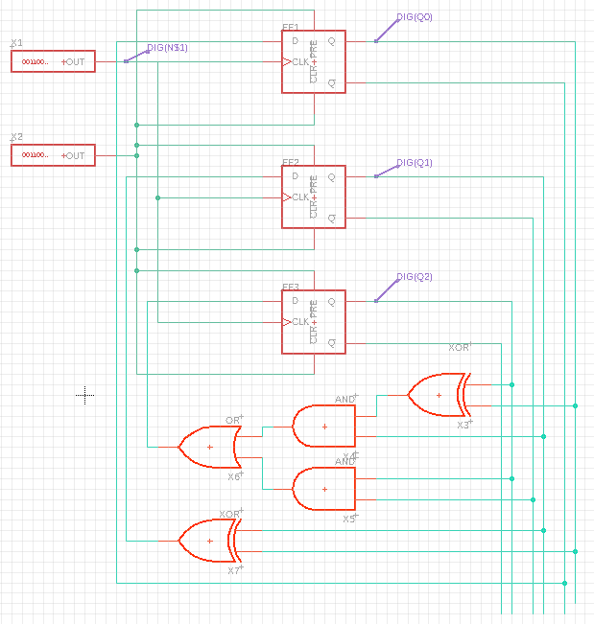
4) Paste your circuit below.
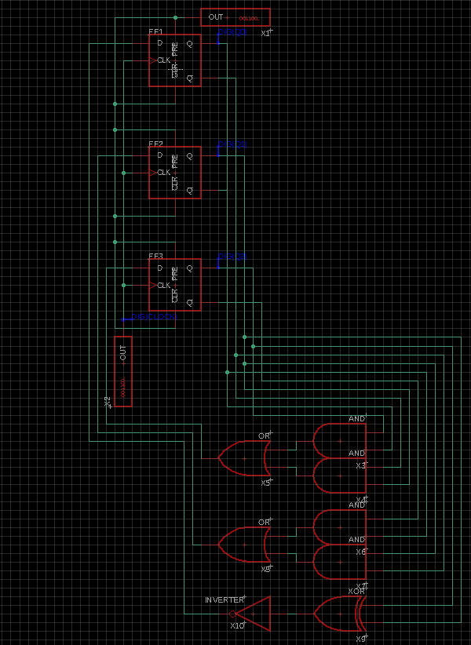

5) Paste the output from your simulation below and annotate it to show that it does indeed implement the Grey counter sequence.
